Day 14 (04 July 2025)
112552596 - vsisukhw - Sukhwinder Singh

For tasks questions , refer
https://docs.google.com/document/d/1jrBrUQckleTPP4L8STbMtJRXPK0d30eUkNbA-X9-ovg/edit?tab=t.0

Task 1
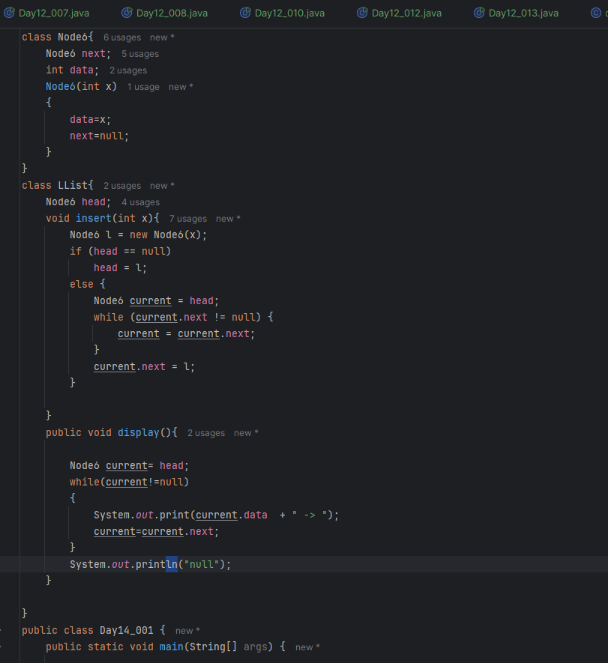
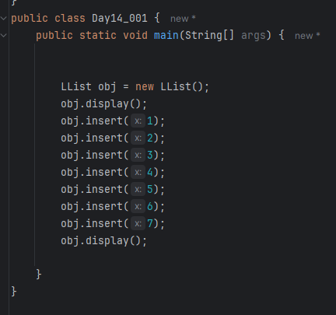
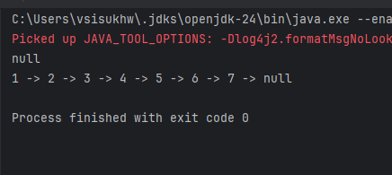

Task 2
Traversing the Linked List meaning :

Traversing a linked list means going through each node in the linked list from the beginning (head) to the end (null), usually to read or process the data stored in each node.
In simple terms:
You're starting at the first node and moving to the next one using the .next reference, and continuing until you reach the end of the list.

1 -> 2 -> 3 -> 4 -> 5 -> null
Traversing means going like this:
- Start at node with value 1 → print 1
- Move to .next → node with value 2 → print 2
- Move to .next → node with value 3 → print 3
- And so on, until .next is null

Task 3
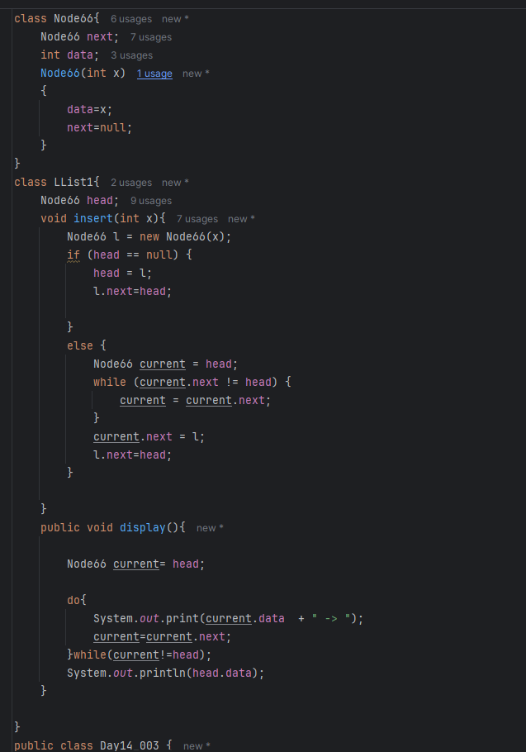
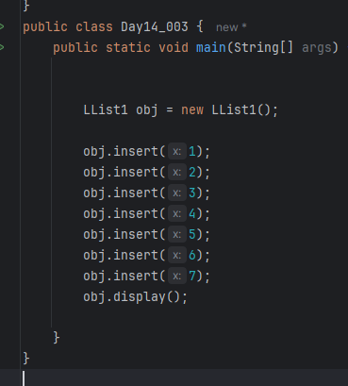
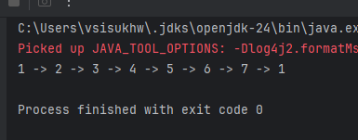

Task 4
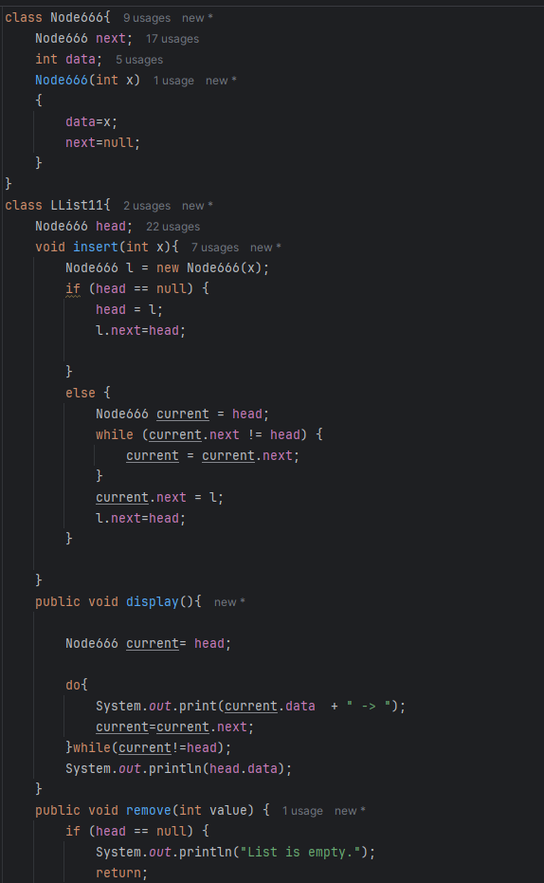
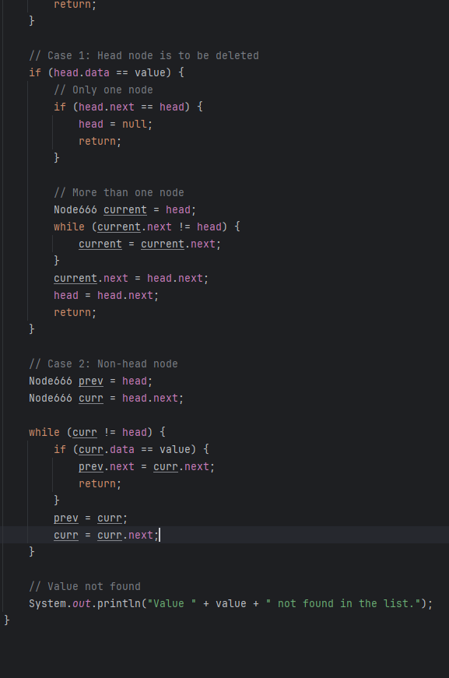
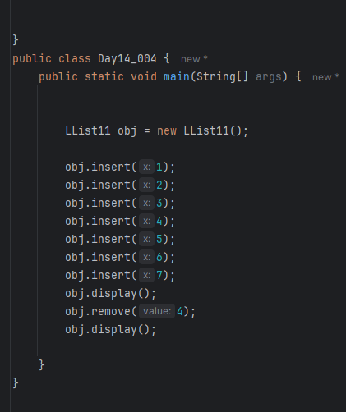
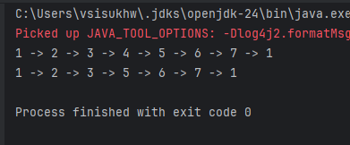

Task 5
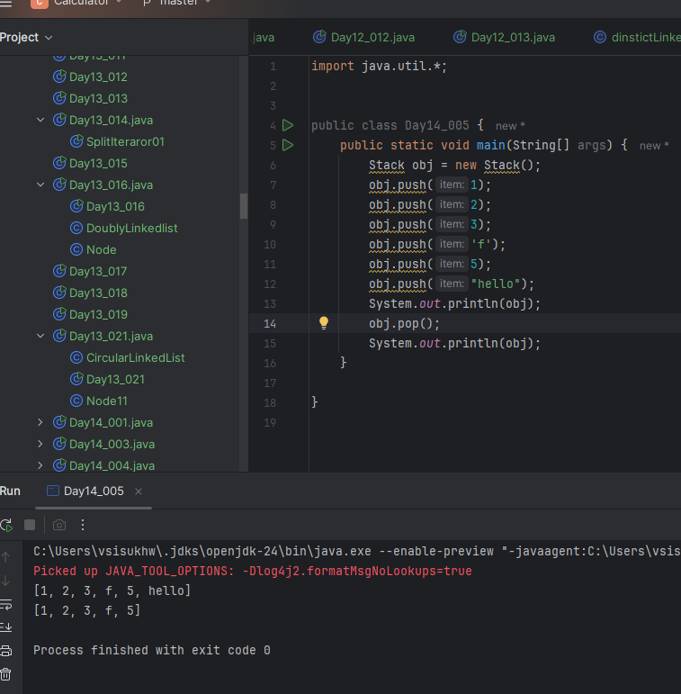

Task 6
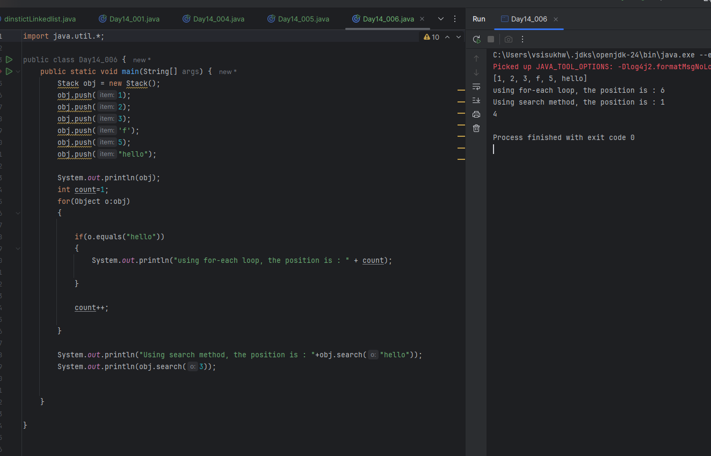

Task 7
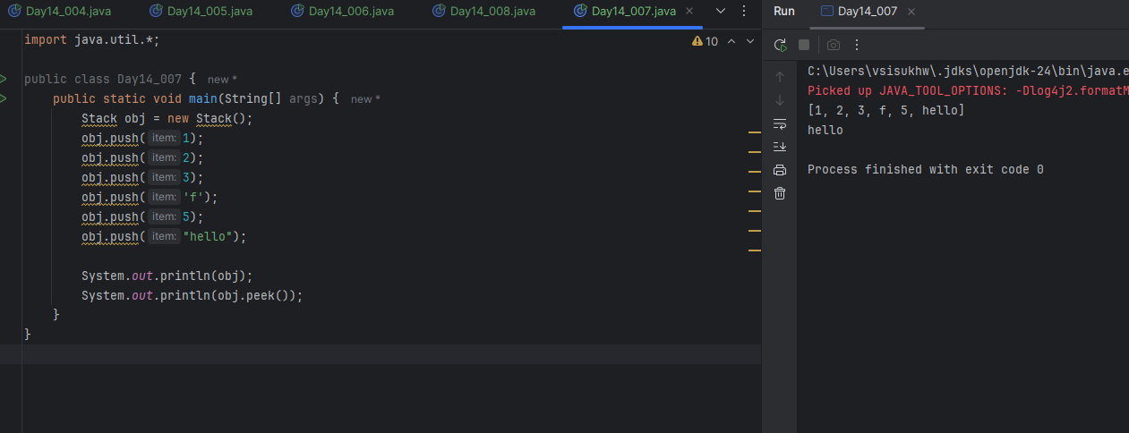

Task 8
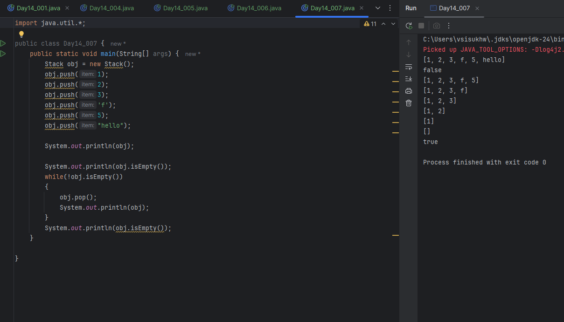

Task 9

Stack Class Methods

- push(E item)
→ Adds an item to the top of the stack.
- pop()
→ Removes and returns the top item from the stack.
- peek()
→ Returns (but does not remove) the top item of the stack.
- empty()
→ Returns true if the stack is empty.
- isEmpty()
→ Also checks if the stack is empty (inherited from Vector).
- search(Object o)
→ Returns 1-based position from the top, or -1 if not found.
- size()
→ Returns the total number of elements in the stack.
- get(int index)
→ Returns the element at the specified index (0-based from bottom).
- contains(Object o)
→ Checks whether the stack contains the given object.
- clear()
→ Removes all elements from the stack.
- iterator()
→ Returns an iterator to traverse the stack elements.

Task 10
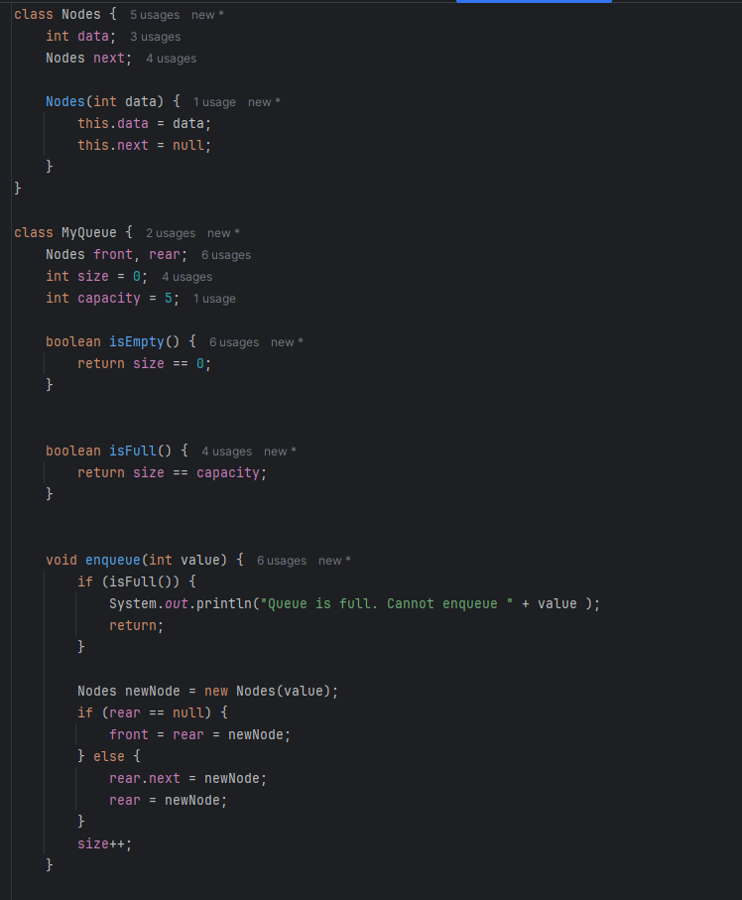
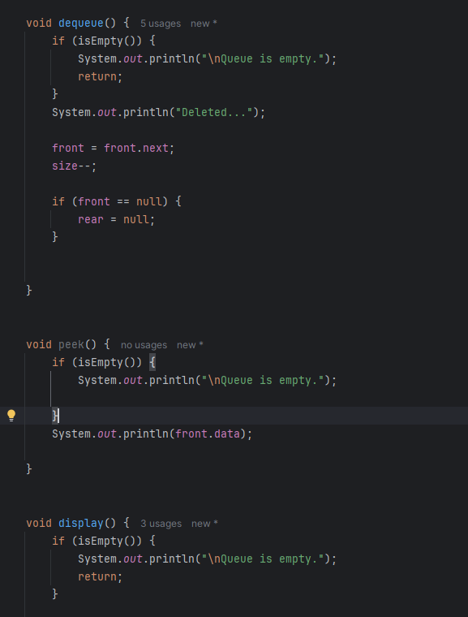
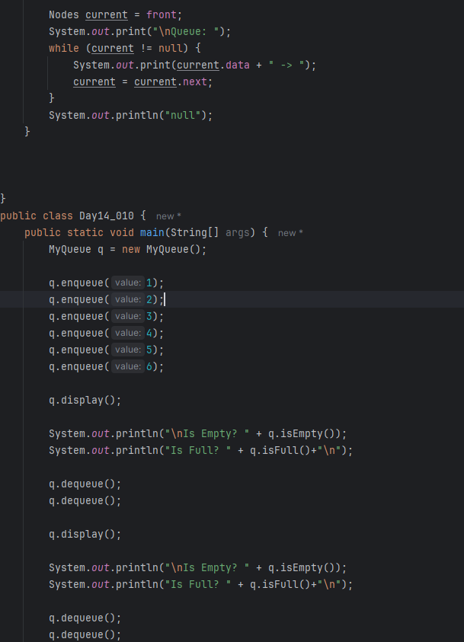
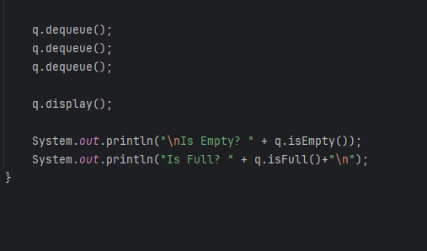
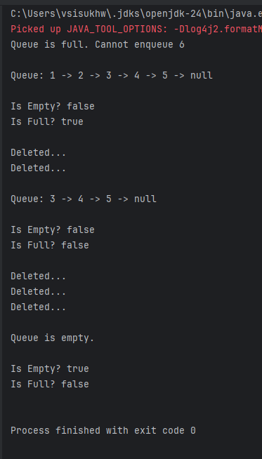

Task 10_Add_on

